TASK 1
func average(of marks: Int...) -> Double {
if marks.isEmpty { return 0 }
return Double(marks.reduce(0, +)) / Double(marks.count)
}
func grade(for avg: Double) -> String {
if avg >= 90 { return "O" }
if avg >= 80 { return "A+" }
if avg >= 70 { return "A" }
if avg >= 60 { return "B" }
return "RA" }
func stats(of marks: [Int]) -> (min: Int, max: Int, average: Double)? {
if marks.isEmpty { return nil }
return (marks.min()!, marks.max()!, average(of: marks))}
func curve(_ marks: inout [Int], by bonus: Int = 5) {
for i in marks.indices {
marks[i] = min(marks[i] + bonus, 100)
}}
var marks = [70, 80, 90]
print(average(of: 70, 80, 90))
print(grade(for: 80))
print(stats(of: marks)!)
curve(&marks)
print(marks)
OUTPUT:
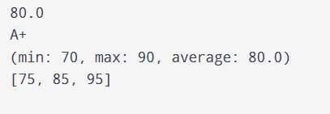
TASK 2
func isPalindrome(_ text: String) -> Bool {
let s = text.lowercased().filter { $0.isLetter }
return s == String(s.reversed())
}
func vowelCount(in text: String) -> Int {
text.lowercased().filter { "aeiou".contains($0) }.count
}
func wordCount(in text: String) -> Int {
text.split { $0.isWhitespace || $0.isPunctuation }.count
}
func wordCount(in text: String, minLength: Int) -> Int {
text.split { $0.isWhitespace || $0.isPunctuation }
.filter { $0.count >= minLength }.count
}
let text = "A man, a plan, a canal: Panama"
print(isPalindrome(text))
print(vowelCount(in: text))
print(wordCount(in: text))
print(wordCount(in: text, minLength: 4))

OUTPUT:
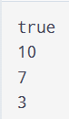

TASK 3
func makeMultiplier(_ factor: Int) -> (Int) -> Int {
return { $0 * factor }
}
let double = makeMultiplier(2)
let triple = makeMultiplier(3)
func apply(_ values: [Int], using transform: (Int) -> Int) -> [Int] {
return values.map(transform)
}
let numbers = [1, 2, 3, 4, 5]
print(apply(numbers, using: double))
print(apply(numbers, using: triple))
print(apply(numbers, using: { $0 * $0 }))

OUTPUT:
